All races start near the statue of Lincoln The Debater in Taylor Park, 900 East Stephenson Street, Freeport, IL.

KIDS RACES (8:00 a.m.)
A series of short distances for children
8 & under - 100 Yards; 9-10 – 200 Yards; 11-12 – 400 Yards
All finishers receive ribbons

The boy and girl winners of each age group will run a 100-yard dash following the 5K to determine…
THE FASTEST KID IN TOWN!

ONE MILE FUN RUN (8:15 a.m.) The course consists of one loop around the historic paved road inside Taylor Park.
This is an untimed fun run.
All finishers receive ribbons

5K RACE (8:35 a.m.)
Course: The course consists of three loops around the historic paved road inside Taylor Park – a 5K (3.1 miles), wheel-measured, certified course that is flat and fast designed to help you achieve a personal best.

5K AGE GROUPS/AWARDS
Male and Female—1st,2nd,3rd - Overall, 14 and under, 15-19, 20-24, 25-29,
30-34, 35-39, 40-44, 45-49, 50-54, 55-59, 60-64, 65-69, 70-74, 75 and over.

WATER/AID: Water on the course; water and refreshments will also be provided at the finish line.

SHIRTS/PREMIUMS
All pre-registered 5K entrants are guaranteed a quality tee shirt. Shirts provided to race day 5K registrants, if available. Sponsored goody bag by Road ID and other sponsors to all.

Packet Pick-up
Race packets for pre-registered entrants may be picked up at the Freeport Family Y on Highland CC Campus Friday, August 10th, 8:00 am- 5:00 pm.

Race Day Registration and Packet Pick-up at Shelter near Start/Finish Line inside Taylor Park at 900 East Stephenson Street, Freeport 7:00 to 8:00 am

ENTRY FEES:

5K Received by August 6th…… . $ 25

Entries received after August 6th… $ 35

Under 18………………..…… $ 15
Rockford Road Runner (Early Only) $22.50
Rockford Wildcats (Early Only).….. $13.50
MILE FUN RUN
Early (by Aug 6th)………. $10.
RRR&RW (Early Only)… $ 8,
Late (After August 6th) $12.

KIDS RACES……………………$2
Complete and sign registration form.
Send entry form portion and check payable to “Family YMCA of NW IL.”

Disclaimer: The Lincoln Douglas 5K/fun Run will take place rain or shine. Organizers reserve the right to cancel the event should weather pose a danger to the safety of the participants and volunteers. Entry fees are not refundable and will be considered a donation to Family Y of NW IL or a United Way Charity if race is cancelled.

__________________________ ________________________ _____/___/____ _____________ _______
Last Name First Name Date of Birth Age on Race Day Sex M / F

__________________________________________ _____________________ __________ ____________
Address City State ZIP
E-mail address: _____________________________________
T Shirt - 5K Only Woman’s__ Man’s___Size: Youth ___ Small __ Med.__ Large___ XL____ XXL_____

Check Event You Are Entering 5K Race/Walk___ Corporate Team*____One Mile Fun Run/Wak___ Kids Race_____
Entry Fee Enclosed___________Additional Tax Deductible United Way Donation_______ Total Enclosed _________

WAIVER: In consideration of this entry, I, intending to be legally bound, hereby, for myself, my heirs, executors, and administrators, waive and release any and all rights and claims for damage I may have as a result of my participation in this athletic contest. I release the sponsors, hosts, City of Freeport, YMCA, Rockford Road Runners and the other organizers and officials of this running/walking event.
* Corporate, four entries must be submitted together. Provide name of team here____________________

SIGNATURE_________________________________________________ Date:________________
(Parent or Guardian if under 18)

__________________________ ________________________ _____/___/____ _____________ _______
Last Name First Name Date of Birth Age on Race Day Sex M / F

__________________________________________ _____________________ __________ ____________
Address City State ZIP
E-mail address: _____________________________________
T Shirt - 5K Only Woman’s__ Man’s___Size: Youth ___ Small __ Med.__ Large___ XL____ XXL_____

Check Event You Are Entering 5K Race/Walk___ Corporate Team*____One Mile Fun Run/Wak___ Kids Race_____
Entry Fee Enclosed___________Additional Tax Deductible United Way Donation_______ Total Enclosed _________

WAIVER: In consideration of this entry, I, intending to be legally bound, hereby, for myself, my heirs, executors, and administrators, waive and release any and all rights and claims for damage I may have as a result of my participation in this athletic contest. I release the sponsors, hosts, City of Freeport, YMCA, Rockford Road Runners and the other organizers and officials of this running/walking event.
* Corporate, four entries must be submitted together. Provide name of team here____________________

SIGNATURE_________________________________________________ Date:________________
(Parent or Guardian if under 18)

__________________________ ________________________ _____/___/____ _____________ _______
Last Name First Name Date of Birth Age on Race Day Sex M / F

__________________________________________ _____________________ __________ ____________
Address City State ZIP
E-mail address: _____________________________________
T Shirt - 5K Only Woman’s__ Man’s___Size: Youth ___ Small __ Med.__ Large___ XL____ XXL_____

Check Event You Are Entering 5K Race/Walk___ Corporate Team*____One Mile Fun Run/Wak___ Kids Race_____
Entry Fee Enclosed___________Additional Tax Deductible United Way Donation_______ Total Enclosed _________

WAIVER: In consideration of this entry, I, intending to be legally bound, hereby, for myself, my heirs, executors, and administrators, waive and release any and all rights and claims for damage I may have as a result of my participation in this athletic contest. I release the sponsors, hosts, City of Freeport, YMCA, Rockford Road Runners and the other organizers and officials of this running/walking event.
* Corporate, four entries must be submitted together. Provide name of team here____________________

SIGNATURE_________________________________________________ Date:________________
(Parent or Guardian if under 18)

T Shirt for 5K Only Circle One: Female Male
Size----Circle One: Small Medium Large XL XXL

Entry Fee ______
RRR/Wildcat Promo Code ______

Mail or Drop off Entry until Thursday, August 9th, 12 Noon

To:

Family Y of Northwest Illinois
2998 W. Pearl City Road Freeport, IL 61032

Register for 5K on line at:

www.itsyourrace.com or

http://lincolndouglas5kandfunrun.itsyourrace.com/

Register Race Day at
Race Site
7:00 am to 8:00 am

Visit our web site at:

www.lincoln-douglas5k.com

RUN ALL 4 Freeport, IL Races
SPRING CHICKEN 05.05.18
Family Y
PRETZEL CITY 5K 06.23.18
Krape Park
LINCOLN DOUGLAS 5K 08.11.18
Taylor Park
COLBY SMITH MEMORIAL RUN
St. Thomas Church 08.25.18

Circle Event You are Entering (ONE EVENT PER APPLICATION) 5K Race One Mile Fun Run Kids Race
_________________________ ________________________ _____/___/____ _____________ _______
Last Name First Name Date of Birth Age on Race Day Sex M / F
__________________________________________ _____________________ __________ ____________
Address City State ZIP
E-mail address: _____________________________________

WAIVER: In consideration of this entry, I, intending to be legally bound, hereby, for myself, my heirs, executors, and administrators, waive and release any and all rights and claims for damage I may have as a result of my participation in this athletic contest. I release and hold harmless the sponsors, hosts, Freeport Park District, City of Freeport, YMCA, Rockford Road Runners and the other organizers and officials of this running/walking event.

SIGNATURE_________________________________________________ Date:________________
(Parent or Guardian if under 18)

SIXTEENTH ANNUAL
LINCOLN DOUGLAS 5K
and FUN RUN

FREEPORT, ILLINOIS

Saturday, August 11, 2018
8:00 a.m.

5K Race, Mile Fun Run
Kids Races
The Fastest Kid in Town

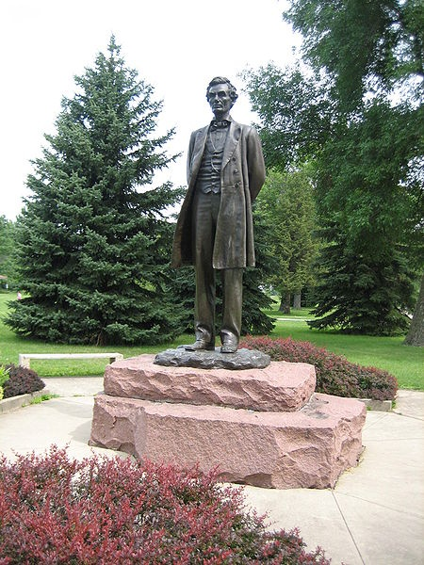

Benefits
United Way Agencies of Northwest IL

Location: Taylor Park
900 East Stephenson Street
Freeport, IL

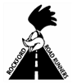The Lincoln-Douglas 5K is a 2018

Rockford Road Runners Circuit Race

