All races start near the statue of Lincoln The Debater in Taylor Park, 900 East Stephenson Street, Freeport, IL.

KIDS RACES (9:30 a.m.)
A series of short distances for children
8 & under - 100 Yards; 9-10 – 200 Yards; 11-12 – 400 Yards
All finishers receive ribbons

The boy and girl winners of each age group will run a 100-yard dash following the 5K to determine…
THE FASTEST KID IN TOWN!

ONE MILE FUN RUN (8:05 a.m.) The course consists of one loop around the historic paved road inside Taylor Park. This is an untimed fun run.

5K RACE (8:20 a.m.)
Course: The course consists of three loops around the historic paved road inside Taylor Park – a 5K (3.1 miles), wheel-measured, certified course that is flat and fast designed to help you achieve a personal best.

5K AGE GROUPS/AWARDS
Male and Female—1st,2nd,3rd - Overall, 10 and under,11-12, 13-14, 15-19, 20-24, 25-29, 30-34, 35-39, 40-44, 45-49, 50-54, 55-59, 60-64, 65-69, 70-74, 75-79, 80 and over.

WATER/AID: Water on the course; water and light refreshments will also be provided at the finish line.

SHIRTS/PREMIUMS
All pre-registered 5K entrants are guaranteed a quality tee shirt. Shirts provided to race day 5K registrants, as available. Sponsored goody bag and other sponsor items to all.

Packet Pick-up
Race packets for pre-registered entrants may be picked up at the Freeport Family Y on Highland CC Campus Friday, August 11th, 8:00 am- 5:00 pm.

Race Day Registration and Packet Pick-up at Shelter near Start/Finish Line inside Taylor Park at 900 East Stephenson Street, Freeport 6:45 to 7:45 am

ENTRY FEES:

5K Received by August 7th …... $ 25

Entries received after August 7th … $ 35

Under 18………………..……. $ 15
Rockford Road Runner (Early Only) $22.50
Rockford Wildcats (Early Only).….. $13.50
MILE FUN RUN by Aug 7th $ 10
RRR&RW (Early Only by Aug 7th) $ 8
Late (After August 7th ) $ 12

KIDS RACES…………………$ 2
Complete and sign registration form.
Send entry form portion and check payable to “Family YMCA of NW IL.”
INTERESTED IN SPONSORING? Contact:
Peter Flynn at p.flynn2@comcast.net
Register for 5K online at Run Signup at https://tinyurl.com/2023LD5K
- - - - - - - - - - - - - - - - - - - - - - - - - - - - - - - - - - - - - - - - - - - - - - - - - - - - - - - - - - - - - - - - - - - - - - - - - - - - - - - - - - - - -
Circle Event You Are Entering (One Event Per Application) 5K Race - One Mile - Kids Race
_____________________ ______________________ _____/___/____ __________ ___
Last Name First Name Date of Birth Age on Race Day Sex M / F
______________________________________ _____________________ ______ __________
Address City State ZIP
E-mail address: ___________________________________________
T Shirt for 5K Only … Size----Circle One: Youth: Large Adult: S M L XL XXL
Entry Fee ____ United Way of NWIL Donation _____ RRR/Wildcat Promo Code _____
WAIVER: In consideration of this entry, I, intending to be legally bound, hereby, for myself, my heirs, executors, and
administrators, waive and release any and all rights and claims to photos or for damage I may have as a result of my participation in this athletic contest. I release and hold harmless the sponsors, hosts, Freeport Park District, City of Freeport, YMCA, Rockford Road Runners, United Way and other organizers and officials of this running/walking event.

SIGNATURE _________________________________________________ Date:____________

Register Race Day at
Taylor Park
6:45 am to 7:45 am
Visit our web site at:
www.lincoln-douglas5k.com

Mail or Drop off Entry received by Thursday, August 10th, 12 Noon

To:
Family YMCA of Northwest Illinois
2998 W. Pearl City Road Freeport, IL 61032

Disclaimer: The Lincoln Douglas 5K/Fun Run will take place rain or shine. Organizers reserve the right to cancel the event should weather pose a danger to the safety of the participants and volunteers. Entry fees are not refundable and will be considered a donation to Family YMCA of NW IL or a United Way Charity if race is cancelled.
RUN ALL 5 Freeport, IL Races
SPRING CHICKEN 05.06.23
Family YMCA 9:00am
PRETZEL CITY 5K 06.24.23
Krape Park 8:00am
FHN Healthy Heart Hustle 07.15.23
Burchard Hills 8:00am
LINCOLN DOUGLAS 5K 08.12.23
Taylor Park 8:00am
COLBY SMITH MEMORIAL RUN
St.Thomas Church 8:00am 08.26.23

TWENTIETH ANNUAL
LINCOLN DOUGLAS RACES

FREEPORT, ILLINOIS

Saturday, August 12, 2023
8:00 a.m.

5K Race, Mile Fun Run
Kids Races
The Fastest Kid in Town

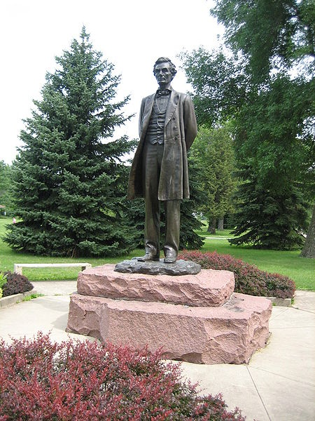

Benefits
United Way Agencies of Northwest IL

Location: Taylor Park
900 East Stephenson Street
Freeport, IL
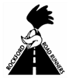The Lincoln-Douglas 5K is a 2023

Rockford Road Runners Circuit Race
www.rockfordroadrunners.org

